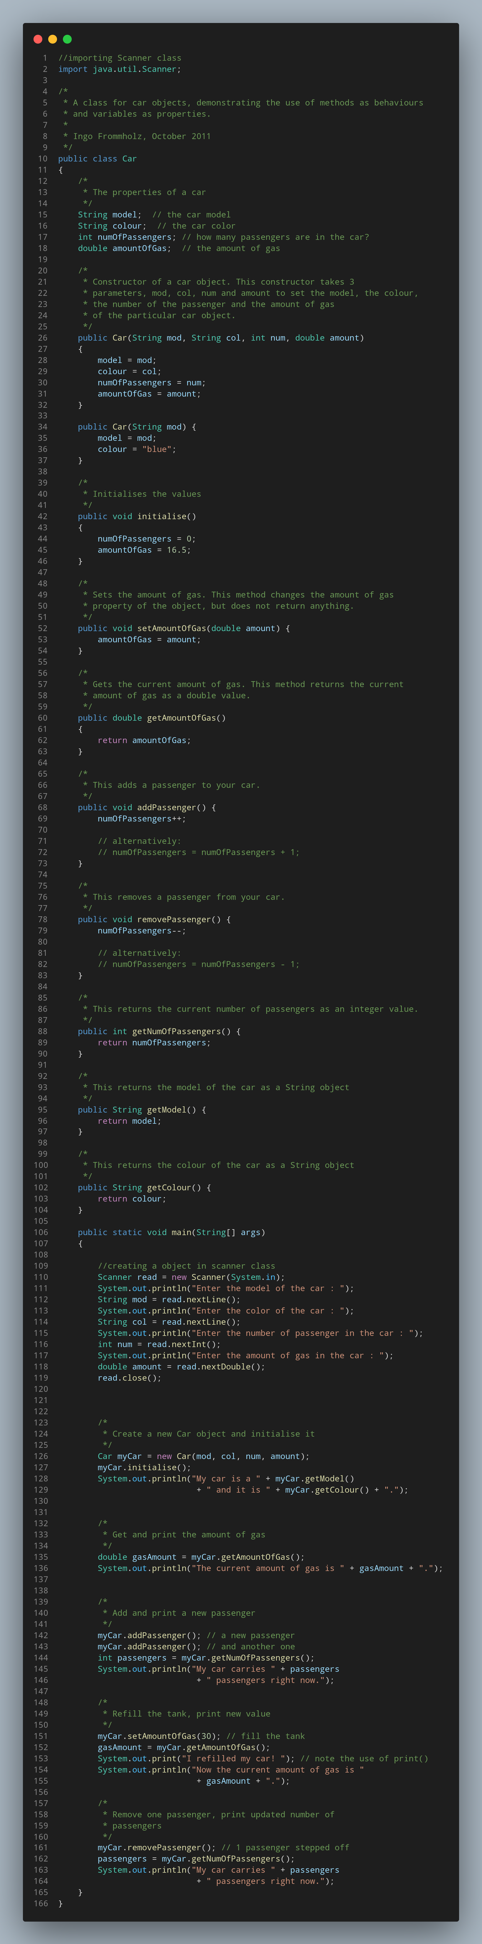

#Doc
Scanner class is imported from package java.util.Scanner.
Class is defined as car.
Public variables are declared.
Construction is defined and arguments are passed.
Number of passengers and amount of gas is added.
Main method is declared.
S object is added in scanner.
Values are read from the console and assigned to unique variables.
Reading sequence is closed.

